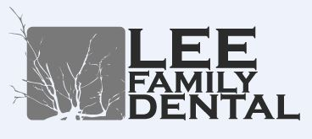

THIS IS AN ABBREVIATED NOTICE DESCRIBING HOW MEDICAL INFORMATION ABOUT YOU MAY BE USED AND DISCLOSED.

The most common reason why we use or disclose your health information is for treatment, payment or health care operations. Some examples of this are: prescribing medications, referring you to another doctor or dental clinic for specialized services, getting copies of your records from other dental or medical offices, asking about your dental insurance plan, sending dental claims to insurance companies on your behalf.

We routinely use your health information inside our office for these purposes without any special permission. If we need to disclose your health information outside of our office for these reasons, we usually will not ask you for special written permission.

APPOINTMENT REMINDERS

We may call or send postcards to remind you of scheduled appointments, or that it is time to schedule an appointment.
You have the right to ask us to communicate with you in a confidential way, such as phoning you at work rather than at home, or by using a specific address to send mail. We will never sell your information to a third party.

A COPY OF THE DETAILED NOTICE OF PRIVACY PRACTICES
IS AVAILABLE TO YOU BY REQUEST

Patient Name_____________________________________________________

Signature_____________________________________ Date________________

